SOUL OF THE RIVER

With my vivifying waters, I nurtured you,

Your civilisation burgeoned on my shores.

Exploiting my benignity devoid of rue,

You accomplished your pleonectic desires.

You owe your progress to my magnanimous ticker.

With every little tad of water, I shed my ichor,

To rejuvenate your subsistence in this sphere,

But you gratified your avarice by tainting me to the core.

Every natural entity is antipathic to its creator,

Like adult-bairns forsake their father and mother.

And yet I would never lament or mither,

Despite your despotic assays to aggrieve me.

I would embrace your atrocities blithely,

For I am your longanimous, solicitous mother.

                                                   -Aadityaamlan Panda

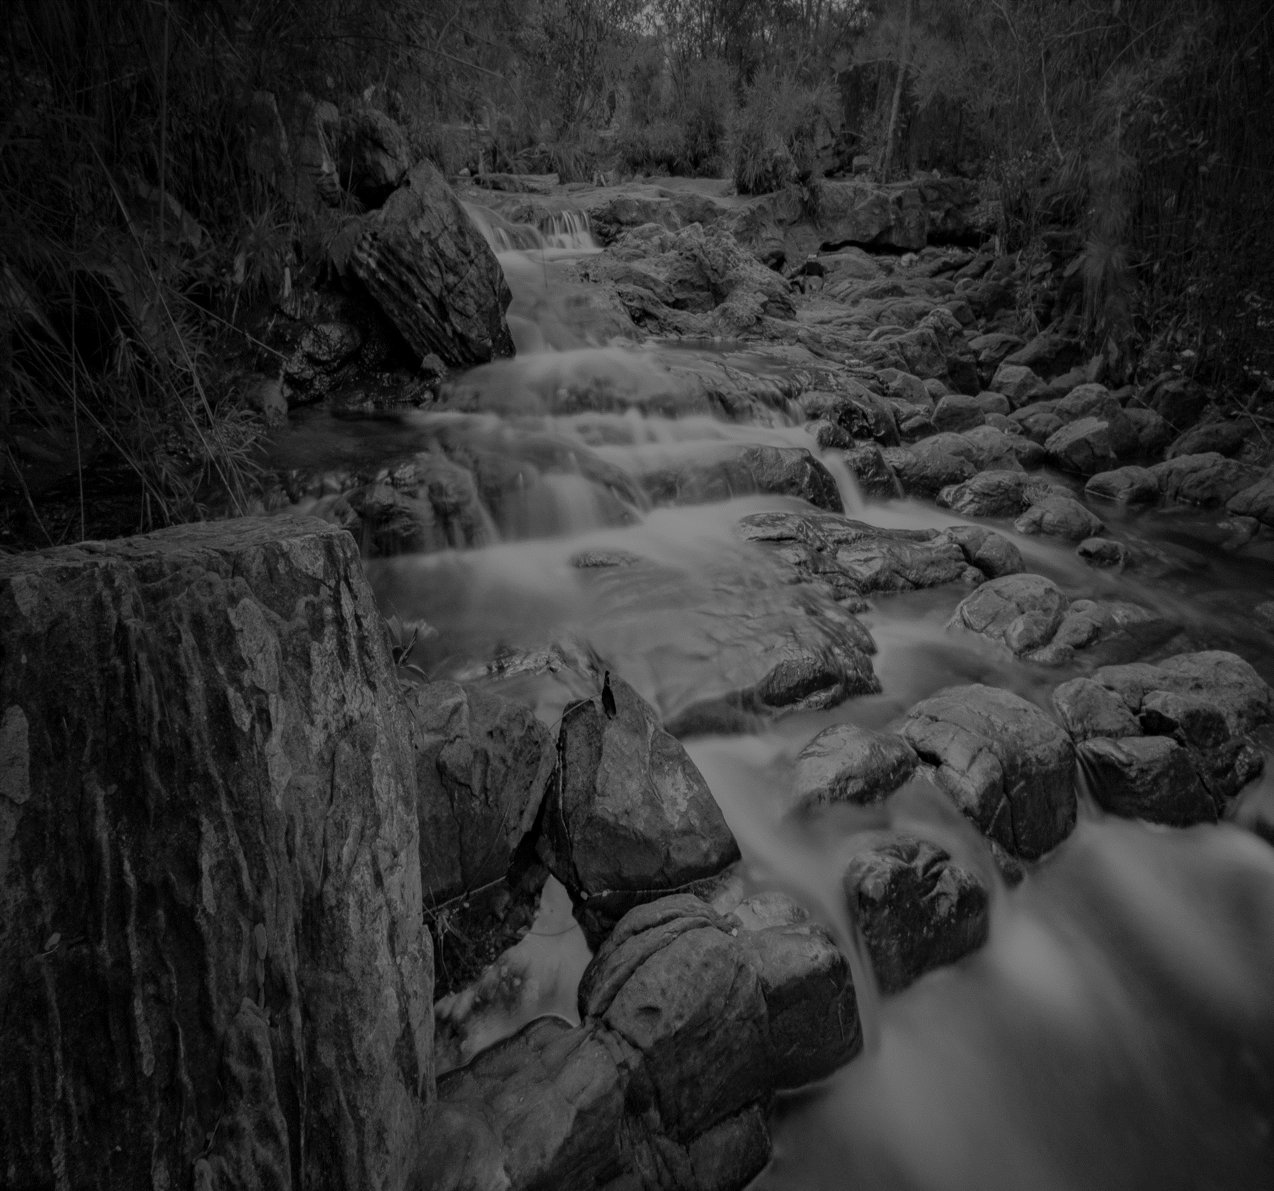

**SOUL OF THE RIVER**

**With my vivifying waters, I nurtured you,**

**Your civilisation burgeoned on my shores.**

**Exploiting my benignity devoid of rue,**

**You accomplished your pleonectic desires.**

**You owe your progress to my magnanimous ticker.**

**With every little tad of water, I shed my ichor,**

**To rejuvenate your subsistence in this sphere,**

**But you gratified your avarice by tainting me to the core.**

**Every natural entity is antipathic to its creator,**

**Like adult-bairns forsake their father and mother.**

**And yet I would never lament or mither,**

**Despite your despotic assays to aggrieve me.**

**I would embrace your atrocities blithely,**

**For I am your longanimous, solicitous mother.**

**-Aadityaamlan Panda**